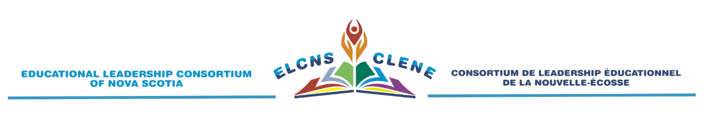
Suite 219, 1496 Bedford Hwy, NS, B4A 1E5 Phone: 902.422.3270 Email: info@elcns.ca



NOVA SCOTIA ASPIRING LEADERS PROGRAM
Applications for Cohort I Beginning August 2025 Now Being Accepted

The Program:
The Nova Scotia Aspiring Leaders Program (ALP) is a professional learning program for teachers, mentors, and department heads who are interested in becoming effective school principals and vice principals. The program is offered by the Nova Scotia Department of Education and Early Childhood Development (DEECD) in partnership with the Educational Leadership Consortium of Nova Scotia (ELCNS) and participating regional centres/boards.
ALP extends over 14 months beginning in August and includes two summer institutes and seven Friday-Saturday seminars. An eight-day residency program with an experienced school principal is integrated throughout the program. A certificate is granted following an exit assessment and successful completion of all program components.
The program has been designed to be a balance between knowledge and skills, theory and practice. Reflection and networking opportunities are incorporated into each seminar and institute.
Application Process:
Applications are submitted through each participating region/board. Applicants must provide three work-related references that include their current supervisor. Personnel from each region/board will review applications and make selections based on identified criteria. All applicants will be notified following the selection process.
Short-listed applicants will be interviewed by personnel from each region/board. The interview panel will make the final selection of successful candidates.
*The deadline for applications for the 2025-26 Cohort H program is April 25, 2025*
For more information about making an application to the ALP, please contact the ALP contact person in your region/board.
Ryan MacDonald, Coordinator of Programs PP-12 & TCRCE ALP Liaison
ryan.macdonald@tcrce.ca
You may also contact Gordon Walters, ALP Coordinator, at gwalters@elcns.ca for more information/questions about the program.

